Bypass AMSI On Windows 11
Compared to detecting payloads on the disk, it is harder for traditional anti-virus products to detect such delivery, while AMSI provides a scanning interface to capture various script languages such as PowerShell, JScript, VBA, or C# code at run time to address the gap.
Amsi stands for “Anti-malware Scan Interface “; it targets malicious script-based malware. The following figure illustrates the process of how AMSI works in high level.
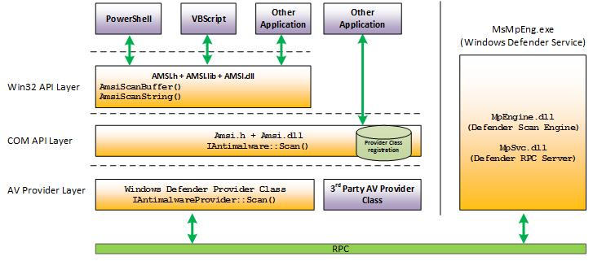
amsi.dll is loaded to each powershell.exe process, providing export functions such as AmsiInitialize, AmsiOpenSession, AmsiScanbuffer, etc. The content of the script is passed into AmsiScanBuffer as an argument. Before the execution, the script will be determined if it is malicious.

In summary, though the process of loading AMSI may involve more steps and be more complex, we know AmsiInitialize is called first, then AmsiOpenSession, and AmsiScanBuffer.
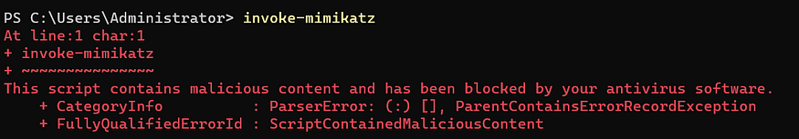

Function AmsiInitialize has 2 arguments, after the execution, the argument amsiContext will be initialized. It is a handle of type HAMSICONTEXT that will be passed to all subsequent calls to the AMSI API.
HRESULT AmsiInitialize(
[in] LPCWSTR appName,
[out] HAMSICONTEXT *amsiContext
);
Function AmsiOpenSession has 2 arguments, either. The 1st argument is amsiContext, which is initialized from the function AmsiInitialize. After the execution, amsiSession will be initialized. It is a handle of type HAMSISESSION that will be passed to all subsequent calls to the AMSI API within the session.
HRESULT AmsiOpenSession(
[in] HAMSICONTEXT amsiContext,
[out] HAMSISESSION *amsiSession
);
Function AmsiScanBuffer has 6 arguments, including previously initialized amsiContext and amsiSession. Other arguments include the script content, the length of the content, the content ID, and the scan result. The value of argument result will be set after the execution.
HRESULT AmsiScanBuffer(
[in] HAMSICONTEXT amsiContext,
[in] PVOID buffer,
[in] ULONG length,
[in] LPCWSTR contentName,
[in, optional] HAMSISESSION amsiSession,
[out] AMSI_RESULT *result
);

According to the result value, scanned script could be considered malicious or clean. AMSI_RESULT_CLEAN is 1, AMSI_RESULT_DETECTED is 32767.

Attack AmsiOpenSession
In OSEP, the bypass method is to patch the first DWORD pointed by amsiContext. The following screenshot is the graph view of AmsiOpenSession on Windows Server 2019. As we can see, the first DWORD is compared to “AMSI“.
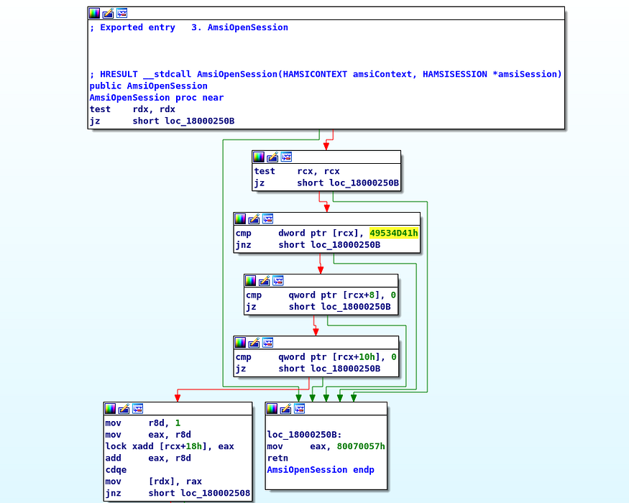
As long as the first DWORD is not equal to “AMSI”, the execution will jump to the following code block:
loc_18000250B:
mov eax, 80070057h
retn
AmsiOpenSession endp

